Single-Photon Double-Slit Interference Experiment

Revised 8/30/2019 16:04:00

Kevin Robb1 and Bill McNulty2

1University of Oklahoma, Homer L. Dodge Department of Physics and Astronomy  
440 W. Brooks St, Norman, OK, USA 73019

e-mail address: kevin.robb@ou.edu

2 University of Oklahoma, Homer L. Dodge Department of Physics and Astronomy  
440 W. Brooks St, Norman, OK, USA 73019

e-mail address: william.p.mcnulty-1@ou.edu

This is an abstract section. Lorem ipsum dolor sit amet, consectetur adipiscing elit, sed do eiusmod tempor incididunt ut labore et dolore magna aliqua. Ut enim ad minim veniam, quis nostrud exercitation ullamco laboris nisi ut aliquip ex ea commodo consequat. Duis aute irure dolor in reprehenderit in voluptate velit esse cillum dolore eu fugiat nulla pariatur. Excepteur sint occaecat cupidatat non proident, sunt in culpa qui officia deserunt mollit anim id est laborum.

1. Introduction

The most essential, fundamental evidence and motivation for quantum physics is that of the wave-particle duality of light. Light demonstrates clear wavelike properties such as refraction and interference, but light was also shown to have a particle nature with Albert Einstein’s photoelectric effect, where discrete quanta of light, “photons,” were measured [1]. Louis de Broglie later showed that all objects have this same wave-particle nature on a small enough scale. The discovery of the wave-particle duality of light opened the door to the exploration of quantum mechanics.

The original double-slit experiment performed by Thomas Young in 1801 was intended to prove that light was a wave. Because we now know light has wavelike qualities, we would expect to see an interference pattern when shining a beam of light through a double-slit onto a detecting surface, and this is exactly what Young saw in his experiment [2].

The first leg of our experiment will involve reproducing Young’s experiment to demonstrate the interference pattern from a beam of light. The really interesting part of this experiment takes place in the latter sections, in which we restrict the beam of light to a single photon going down the channel at a time. Each photon will pass through both slits simultaneously, interfering with itself and producing an interference pattern on the detector just as if there was a beam of many photons. If we attempt to “tag” each photon to discover which slit it went through, the interference pattern disappears. This is consistent with previous discoveries which indicate that although a wave-particle duality exists, photons can exhibit only one set of qualities at a time.

1. Theory and Background

When light acts as a wave, it has the same characteristics of any wave, namely a wavelength, amplitude, and frequency. As such, we expect Huygen’s principle and the principle of superposition to apply, causing the light to go through the double slit, exiting in two bands that interfere as they travel. Figure 1 shows this interference as well as the pattern this produces on the detector.

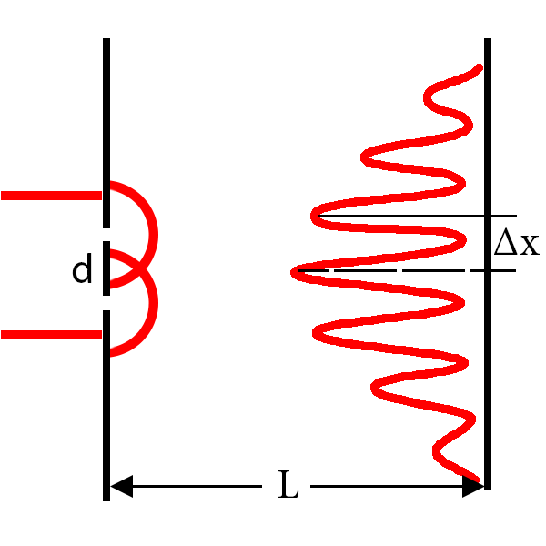

FIG. 1. Two-slit interference pattern. This figure shows diffraction due to Huygen;’s principle and the resulting interference pattern from an incoming beam of photons.

In addition to this wavelike property of interference, we need to take into account the rate at which light particles (photons) are exiting the bulb and passing the double slit. This rate is akin to the intensity of the light waves. For the laser, this rate is rather high, making it unclear if photons are interfering with themselves or with others. When we switch to the incandescent bulb with a green filter, this rate goes down so drastically that there is either 0 or 1 photon in the entirety of the channel [3]. At this point, we can safely assume we are measuring the interference patterns of single photons with themselves, thus demonstrating the wave-particle duality of light.

We will be using an approximation in the manual because L, the distance between the double slit and the detector, is much larger than Δx, the distance between adjacent maxima on the interference pattern. This approximation, given by

$\frac{∆x}{L}=\frac{λ}{d}$, (1)

allows us to calculate λ, the wavelength of the laser light, given the slit separation, d. We will compare our result to the expected wavelength enumerated in the manual to ensure the apparatus is working correctly and that we are recording the interferece pattern accurately. We will also use our data to reproduce the interference pattern and compare it to those found in similar experiments and in the manual.

1. Apparatus and Experiment

This section will have information and diagrams about the apparatus and experiment.

1. Analysis and Discussion

This section will contain analysis and discussion.

1. Conclusions

This section will contain conclusions of the experiment.

[1] Serway, R. A. (1990). Physics for Scientists & Engineers (3rd ed.). Saunders. p. 1150. ISBN 0-03-030258-7.

[2] Robinson, Andrew (2006). The Last Man Who Knew Everything. New York, NY: Pi Press. pp. 123–124. ISBN 978-0-13-134304-7.

[3] TeachSpin Instruction Manuals. Two-Slit Interference, One Photon at a Time (TWS2-A); Pulse Counter/Interval Timer (PCIT1). Rev 2.0, 6/2013.